Project 1

Section 1

1. INSERT INTO

Project (project_id,project_title,project_manager,project_budget)

VALUES(1,"Pension System","M Phillips",25500);

INSERT INTO

Project (project_id,project_title,project_manager,project_budget)

VALUES(2,"Salary System","H Martin",15500);

INSERT INTO

Project (project_id,project_title,project_manager,project_budget)

VALUES(3,"HR System","K Lewis",10500);

1. INSERT INTO

Department(dept_id,dept_name)

VALUES(100,"IT");

INSERT INTO

Department(dept_id,dept_name)

VALUES(101,"HR");

INSERT INTO

Department(dept_id,dept_name)

VALUES(102,"DB");

1. INSERT INTO

employee(employee_id,employee_name,dept_id)

VALUES(200,"A Smith",100);

INSERT INTO

employee(employee_id,employee_name,dept_id)

VALUES(201,"B Lewis",100);

INSERT INTO

employee(employee_id,employee_name,dept_id)

VALUES(202,"D Rich",101);

INSERT INTO

employee(employee_id,employee_name,dept_id)

VALUES(203,"E Ford",101);

INSERT INTO

employee(employee_id,employee_name,dept_id)

VALUES(204,"F James",102);

1. INSERT INTO

Proj_Emp(project_id,employee_id,hourly_rate)

VALUES(1,200,25);

INSERT INTO

Proj_Emp(project_id,employee_id,hourly_rate)

VALUES(1,201,18.5);

INSERT INTO

Proj_Emp(project_id,employee_id,hourly_rate)

VALUES(1,202,21);

INSERT INTO

Proj_Emp(project_id,employee_id,hourly_rate)

VALUES(2,203,20);

INSERT INTO

Proj_Emp(project_id,employee_id,hourly_rate)

VALUES(2,204,17);

INSERT INTO

Proj_Emp(project_id,employee_id,hourly_rate)

VALUES(3,201,17.5);

INSERT INTO

Proj_Emp(project_id,employee_id,hourly_rate)

VALUES(3,202,16.25);

Section 2

1. SELECT project_title, project_manager, project_budget,

Employee.employee_name,

Department.dept_name,

Proj_Emp.hourly_rate

from Project

INNER JOIN Proj_Emp

ON Project.project_id=Proj_Emp.project_id

INNER JOIN Employee

ON Proj_Emp.employee_id=Employee.employee_id

INNER JOIN Department

ON Employee.dept_id=Department.dept_id

ORDER BY 1,2,3,4;

1. SELECT employee_name,

MAX(Proj_Emp.Hourly_rate) as 'max_hourly_rate'

from Employee

INNER JOIN Proj_Emp

on Employee.employee_id=Proj_Emp.employee_id

GROUP BY Employee.employee_name;

1. SELECT project_title,

Employee.employee_name,project_budget

from Project

INNER JOIN Proj_Emp

ON Project.project_id=Proj_Emp.project_id

INNER JOIN Employee

ON Proj_Emp.employee_id=Employee.employee_id

where Project.project_budget=

(SELECT MIN(Project.project_budget)

From Project);

1. SELECT employee_name,

d.dept_name,

pe.Hourly_rate

From Employee e

INNER JOIN Proj_Emp pe

ON e.employee_id=pe.employee_id

INNER JOIN Department d

ON e.dept_id=d.dept_id

WHERE pe.Hourly_rate=

(SELECT MAX(pe2.Hourly_rate)

FROM Proj_Emp pe2

INNER JOIN Employee e2

ON pe2.employee_id=e2.employee_id

INNER JOIN Department d2

ON e2.dept_id=d2.dept_id

WHERE d.dept_id=d2.dept_id);

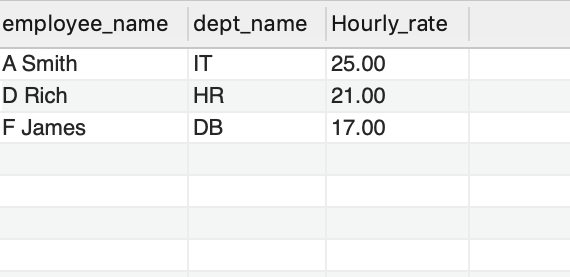

1. SELECT employee_name,

Department.dept_name,

Proj_Emp.Hourly_rate,

RANK() OVER(PARTITION BY Department.dept_name

ORDER BY Proj_Emp.Hourly_rate DESC)

as 'Rank'

FROM Employee

INNER JOIN Proj_Emp

ON Employee.employee_id=Proj_Emp.employee_id

INNER JOIN Department

ON Employee.dept_id=Department.dept_id;

